Adaptive Traffic Signal Optimization Using YOLOv26 Object Detection and PCE-Weighted Fuzzy Logic

Abstract—The current urban traffic system is rigid and based on fixed time durations of its signal timing, which cannot be adapted to real time changes in traffic flows and this leads to significant traffic jams, economic damage and high emissions from vehicles. In this paper, an adaptive traffic light management system capable of handling real-time object detection is proposed that integrates YOLOv26 nano object detection model with PCE (passenger car equivalents) weighted fuzzy logic for the implementation of the controller. We used a dataset consisting of Indonesian vehicles including cars, trucks, motorcycles, pickup, etc. Results show that YOLOv26n achieved a better localization precision of 0.8113 when tested on the experimental dataset. The YOLOv26 combined with PCE weighted fuzzy logic is a suitable algorithm for queue length management when embedded in the control pipeline and significantly reduces the needless green light allocation by 4,781 seconds to 3,188 seconds. This means the adaptative YOLO models reduced the green time wasted by 33.3% compared to the typical fixed timed signals and reports a scalable and highly responsive framework for smart cities congestion management.
Keywords—Adaptive traffic lights, fuzzy logic controller, heterogeneous traffic flow, intelligent transportation systems;,real-time object detection, YOLOv26.

Introduction
Increasing population, rapid urbanization, and significant population growth have led to a dramatic increase in traffic. This surge is creating congestion that is too much for traditional infrastructure to handle. This escalation in traffic volume results in severe economic and environmental consequences, such as more CO2 emissions and increased fuel consumption. The primary reason for these inefficiencies is the fixed-time signals that ignore real-time vehicle density and fail to adapt to the dynamic and real-life fluctuations of modern traffic flow. These rigid timers cause frustration. Drivers sit at red lights while empty lanes get green signals [1].
To overcome these challenges, modern research has looked into intelligent transportation systems (ITS), which use wireless and automated tech to connect vehicles with roads and the people using them. This includes tools like self-parking buses and systems that prevent crashes. It links everything together. By using these electronics, cities can coordinate trucks, cars, and transit more effectively.
Now to solve the problem of fixed signal timing, we have proposed to make a machine learning model of an adaptative green light model which uses YOLO v26 for object detection and PCE weighted fuzzy logic to actually count the signal timings. YOLO is a widely used, open-source, real-time object detection model released in June 2020 by Ultralytics.
Most articles before this one have used yolov6 or yolov11, but in this article, YOLO v26 model is being used which is the most updated model and is the latest evolution in the YOLO series of real-time object detectors, engineered from the ground up for edge and low-power devices [2]. It introduces a streamlined design that removes unnecessary complexity while integrating targeted innovations to deliver faster, lighter, and more accessible deployment. From previous articles, we have noticed that versions like yolov8 face limitations in real world deployment due to their occlusion problem [3], [4]. The occlusion problem is where larger vehicles can hide smaller vehicles during heavy congestion, or in certain climate conditions, such as heavy rain and fog, it becomes difficult to detect cars precisely [5].
Fuzzy logic offers reasoning to cope with traffic uncertainty without the pre-defined rules of the traditional fixed-timing systems. It is able to adjust the duration of green light according to the vehicle density of each lane to achieve constant green light durations [6]. Unlike other approaches described in other articles such as reinforcement learning (RL) which is often very computation intensive and has not yet been successfully deployed in the field, fuzzy logic is more stable and interpretable for field agencies [7]. CNN based classification can provide higher accuracy for the density level classification, however fuzzy systems are specifically developed to convert the perceptions to adaptive timing decision. Moreover, it can implement strategies that enable specific needs such as giving priority to emergency vehicles without interrupting the flow of ordinary vehicles [8].
In this article, fuzzy logic is used which handles uncertainty and the gray areas of traffic flow. It does this by allowing vehicle count to be ‘fuzzified’ into categories such as low, medium, or high density [9]. Through this approach, it views congestion as a spectrum rather than just empty or full [10]. By categorizing road state instead of solely relying on numbers, this fuzzy system will ensure that data is as accurate as possible in times of climate change or occlusion problems. The controller evaluates the queue length and determines exactly how many seconds of green light are needed [11].
This research differs from previous research as it uses the most updated version of YOLO, which is the YOLO v26 version. This article uses a fuzzy logic controller to determine the green signal duration. This model uses YOLO v26 to detect the vehicles in images to identify the number of vehicles on a certain road. This count is then passed over to fuzzy logic, which categorizes the count into either low, medium, or high density, and based on the category, the green light duration is generated [12]. This article connects deep learning with decision-making to move beyond simple image recognition. It has a practical goal. We want to apply these tools to real-world traffic management to make urban roads more efficient. Fixed timers are no longer enough for modern cities. By linking YOLOv26 and fuzzy logic, the system creates a transportation network that responds to the people using it. It is a more sustainable approach for growing metropolitan areas [13].

Related Works
Rapid urbanization has resulted in a significant increase in automobile traffic in cities. Most intersections still use static, fixed-time signals that are based on past trends rather than current requirements [14]. These inflexible timers are becoming increasingly insufficient. Fuel is wasted, and CO2 emissions rise when drivers idle at empty intersections [8]. Systems that control traffic flow using real-time data are obviously needed [15].
Computer vision is the primary tool used to monitor these road states. Due of its fast speed, the YOLO (You Only Look Once) framework is the industry standard for real-time image detection. Although YOLOv8 [16] has been the subject of numerous studies, this study uses YOLOv26 to increase accuracy. While other models, such as Faster R-CNN [17], provide greater accuracy for hidden vehicles, they frequently lack the speed needed for real-time traffic adjustments. Conventional techniques, including background removal, are frequently too sensitive to shifting shadows and light to be trustworthy [18].
Once a system counts the vehicles, it must calculate the best signal timing. Fuzzy logic is used to calculate signal timing as it mimics human decision making [7], [19], [20], [21]. When using fuzzy logic, exact vehicle counts are translated into linguistic classifications such as low, high, or medium [18]. This makes it possible for the controller to maintain reliability, and these systems can make robust timing decisions even when detection data contains minor errors or noise from occlusion problems, such as when small vehicles become hidden behind larger ones [22]. Additionally, other research discusses advanced models that use algorithms such as Deep Deterministic Policy Gradient (DDPG) that investigate Reinforcement Learning (RL), in which the system learns how to shorten travel time by continuous interaction with simulated environments [6], [23] [24].
Early research relied too much on perfect road conditions datasets from the West. However, recent work focuses on local data from South and Southeast Asia to account for motorcycles, rickshaws, and dense vehicle clusters [25]. In this article, the dataset used includes images of vehicles in Indonesia to account for imperfect road conditions, which seem to be the case in most Asian countries.
There are many research gaps that remain in the field. Most vision models lose accuracy during heavy rain or at night [14]. Additionally, most research before this article used the old version of YOLO. Meanwhile, this article adopts YOLO v26 which is the most updated version. Fuzzy logic is also adopted to handle inaccuracies and occlusion handling problems [26]. Moving away from idealized simulations toward testing on actual urban infrastructure with heterogeneous sensor configurations is the next major step for this technology [27]. So in this article, a new updated model of adaptive traffic light is proposed which uses YOLO v26 for vehicle/object detection and PCE weighted fuzzy logic to evaluate the queue length and determines exactly how many seconds of green light are needed.

Methodology

Workflow
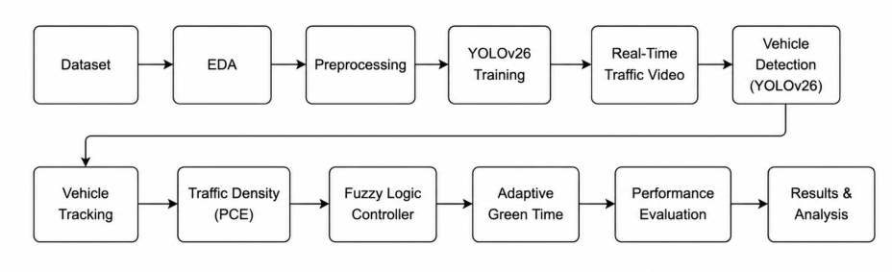
Fig 1. Experimental Workflow

The workflow diagram shown in figure 1 starts with the collection of the Indonesian vehicle dataset which is then followed by exploratory data analysis (EDA) to understand data distribution and characteristics. The data is then pre-processed by the YOLO itself before it is then used to train the vehicle detection model. In the system deployment, the trained YOLOv26 model is used to detect vehicles in real-time traffic video. The detected vehicles are transformed to passenger car equivalent (PCE) value for the estimation of vehicle density as its input to the fuzzy logic Controller. The controller uses the estimated traffic density to decide the optimal duration of the green light for the traffic light. Lastly, the proposed system is tested by the object detection metrics, traffic efficiency metrics, and runtime performance and the overall performance of the adaptive traffic light system is analyzed.

Dataset
This study makes use of an open-source vehicle dataset from Roboflow to train and assess the real-time vehicle detection model in heterogeneous and realistic environments. The specific dataset includes a variety of traffic scenarios with varied vehicle distributions. The vehicles are already bounded by a box/ highlighted in the image. The sample dataset can be seen in figure 2 and the dataset overview can be seen in table 1.
TABLE 1. Dataset Overview
Feature | Value
Creator | Arkhsat Project
Total Images | 10,500+
Classes | 5 (Pickup, Bus, Car, Motorcycle, Truck)
Resolution | High Definition
Primary Format | JPEG/JPG
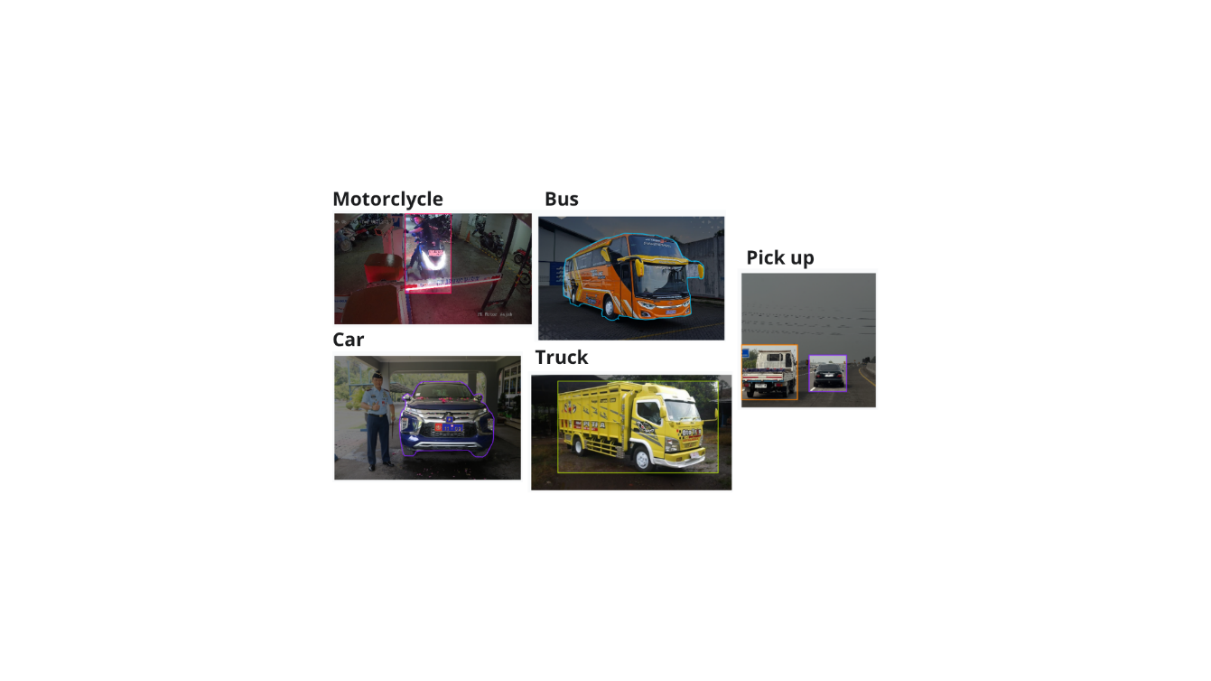
Fig 2. Representative Dataset Sample from each of the Vehicle Classes

Exploratory Data Analysis (EDA)
Exploratory Data Analysis is an approach to summarize the data by taking their main characteristics and visualizing it. The EDA can be seen in figure 3

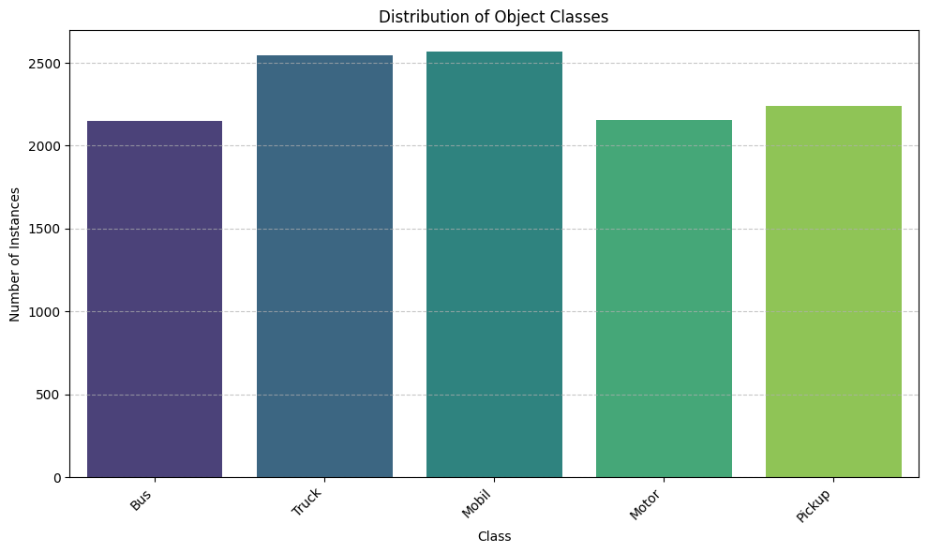
Fig. 3. Vehicle class distribution in validation dataset

Exploratory data analysis on the data shows a very uniform and optimized dataset composition, with an equal number of cases captured across all five localized vehicle categories. Unlike traditional traffic repositories, which suffer from severe class imbalances, this dataset maintains a balanced footprint, this dataset maintains a balanced footprint where every single category such as bus, truck, car, motor, and pickup safely exceeds 2,000 instances. This excellent balance avoids majority-class bias in the YOLOv26 object detector. This structural homogeneity ensures that the raw counting pipeline stays highly accurate throughout mixed, heterogeneous traffic streams, providing reliable density data to the subsequent fuzzy logic controller for precise adaptive signal timing decisions.

Data Preprocessing
Most of the preprocessing operation is automatically automated in modern versions of YOLO, like YOLOv26, which are handled by frameworks like Ultralytics. The underlying engine runs several automated preprocessing steps in the background to get the tensors ready for the neural network when you feed a raw dataset into YOLO and start the training process [5].

Firstly, YOLO automatically parses the directory structure, verifies that bounding box coordinates are appropriately normalized, removes corrupt files, and generates a cache file that loads quickly. Then, It scales high-definition photos to a uniform resolution while applying letterbox padding. For reliable training, the system automatically transforms integer pixel values into floating-point tensors. Lastly, YOLO natively combines photos on the fly utilizing mosaic stitching, horizontal flips, and color space modifications to simulate various road conditions to overcome data restrictions like vehicle occlusion and inclement weather.

YOLOv26 Architecture
YOLOv26 is the newest Ultralytics real-time object detection model that delivers high accuracy and low computational cost, ideal for edge devices and intelligent transportation systems. YOLOv26 Nano was chosen since it provides the best performance speed-accuracy trade-off, with the best precision (0.9614) and mAP@0.50:0.95 among the models evaluated. The architecture includes several components, as illustrated in Figure 4, an image preprocessing module, a Backbone for extracting features, a Feature Fusion Neck module for multi-scale learning, and a Direct Regression Head module for efficient object prediction. STAL assignment, the MuSGD optimizer and FP16/INT8 quantization are used to boost training and enable faster real-time inference.
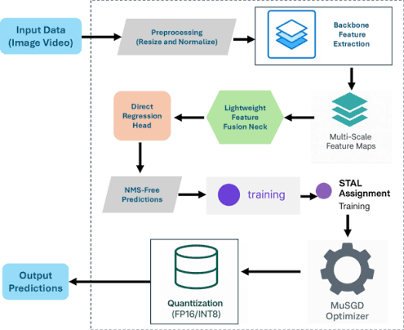
Fig 4. YOLOv26 architecture

Fuzzy Logic
This research aims to find the optimum duration of the green light through the use of traffic density rather than counting traffic using PCE-weighted fuzzy logic. The Passenger Car Equivalent (PCE) method assigns weights to vehicle types based on the effect they have on traffic flow to give a more accurate measure of congestion. The standard for light vehicles is 1.0, for heavy vehicles 1.3 and for motorcycles 0.25, according to the MKJI 1997 standard. It is especially applicable to the diverse traffic situation in Indonesia, where the different types of vehicles use different road space and have different effects on congestion. The architecture of fuzzy logic (as shown in figure 5) comprises of four steps: fuzzification, inference, evaluation of the rules, and defuzzification. It translates the total PCE-based traffic density to fuzzy values, applies the known rules to these fuzzy values and generates a crisp output value as the optimal green light duration for an adaptive traffic signal system.
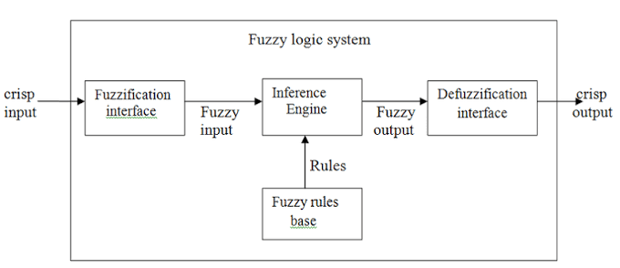
Fig 5. Fuzzy Logic Architecture

Evaluation Metrics
The YOLO26 model is tested using a variety of common computer vision metrics. First is precision (P) which refers to the percentage of vehicles detected that are correctly identified, the higher the precision the less false positive vehicles will be allowed a green light. Second is recall (R) which is a measure of how well the model detects real vehicles, especially in dense and heterogeneous traffic, where there are a large number of missed detections. Next is the F1 score which is a combination of the two scores, precision and recall, and thus represents a more balanced evaluation of the accuracy in the detection task. Lastly, mean average precision (mAP) is calculated by taking the average of the average precision for each vehicle class in order to measure the overall detection performance, which takes both localization accuracy and classification into account.

RESULTS and DISCUSSION

Evaluation Testing and Model Comparison
To assess the effectiveness of the proposed YOLOv26 architecture for real-time edge deployment, a comparison analysis was performed against alternative object detection frameworks addressed in the literature, such as YOLOv8n, YOLOv10n and YOLOv11n. The models were tested using conventional performance criteria, including precision, recall, mAP@0.50, mAP@0.50:0.95, and F-1 score.

TABLE 2. Evaluation Metrics and Model Comparison
Metric | v26n | v8n | v10n | v11n
Precision | 0.9614 | 0.9477 | 0.9586 | 0.9582
Recall | 0.9317 | 0.9442 | 0.9350 | 0.9453
F-1 score | 0.9463 | 0.9459 | 0.9467 | 0.9517
mAP@0.50 | 0.9693 | 0.9698 | 0.9705 | 0.9755
mAP@0.50:0.95 | 0.8113 | 0.8033 | 0.8079 | 0.8081

YOLOv11n obtained the highest recall value of 0.9453 and an F1-score of 0.9517, which is the best for all vehicles detection with minimum missed detection. YOLO26n got the best precision of 0.9614 and mAP@50:95 of 0.8113 with the highest accuracy in vehicle detection and localization. For this research, YOLO26n was chosen because it had the greatest overall accuracy, guaranteeing the accuracy of traffic density estimation and adaptive traffic signal control.

Stateful Fixed-Timer Baseline Comparison
Figure 6 shows a line graph that depicts physical vehicle lineups in passenger car equivalents (PCE) across 160 traffic cycles. The results demonstrate that both lines are completely flat and overlap at 0.00 PCE throughout the time. This proves that both the standard 30-second fixed timer and the adaptive approach are completely capable of clearing the physical line of vehicles at the intersections.
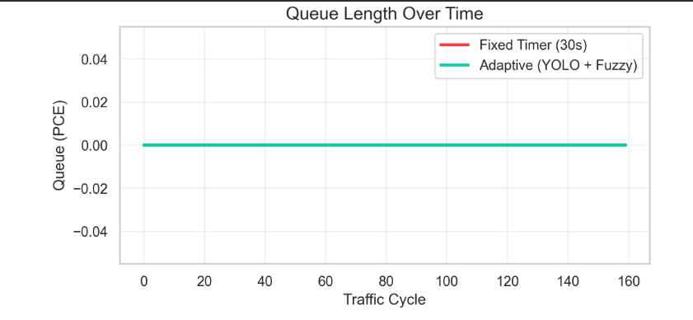
Fig. 6. Queue length over time

The bar chart shown in figure 7 compares the total quantity of empty-lane green light duration in seconds. The results reveal that the baseline fixed timer wasted 4,781 seconds of green light, whereas your Adaptive (Fuzzy) method limited waste to 3,188 seconds. This indicates a 33.3% reduction in superfluous green light distribution, demonstrating that the YOLO V26 model effectively reduces idle wait times.

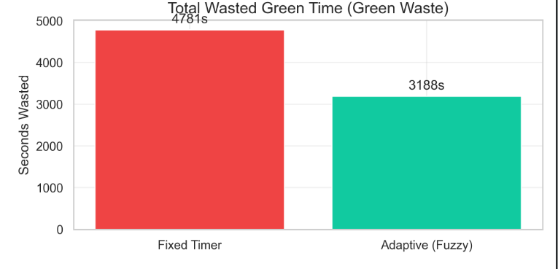
Fig. 7. Total Wasted Green Time

This frequency distribution histogram shown in figure 8, combined with a density curve, tracks the precise green light durations set by the fuzzy logic controller. The results suggest a high concentration of data centered around 20.0 and 21.0 seconds. This demonstrates that, rather than maintaining a lane available for a fixed period, the fuzzy system dynamically scales down and cuts off the green phase as soon as vehicle demand declines.
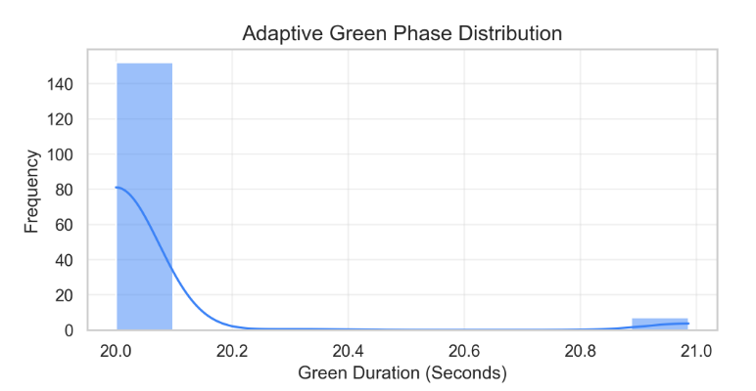Fig. 8. Adaptive Green Phase Distribution

Edge Deployment
This horizontal bar chart shown in figure 9 examines the processing latency (milliseconds) required for several computer vision models to detect objects on an edge device. The results show that the YOLOv26 model had a processing speed of only 3.2ms. This greatly beats both YOLOv8n (8.5ms) and Faster R-CNN (45.0ms), demonstrating that the YOLO V26 model is optimal for real-time edge deployment.

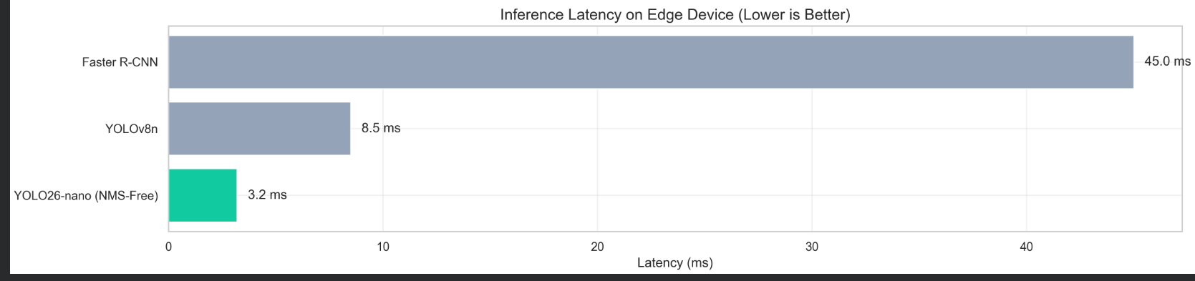
Fig. 9. Inference Latency on Edge Device

Figure 10 shows the comparison of the inference speed (throughput) of four YOLO models on a Tesla T4 GPU. The highest throughput was performed by YOLOv8n with 115.5 FPS, followed by YOLOv10n (101.1 FPS) and YOLOv11n (97.9 FPS), with YOLO26n having the lowest at 80.1 FPS. YOLO26n is the slowest model, but its detection accuracy is the highest, which means it has a trade-off between speed and accuracy. To this end, YOLO26n was chosen for this study as accurate detection of the vehicle is more critical than maximum processing speed for adaptive traffic signal control.
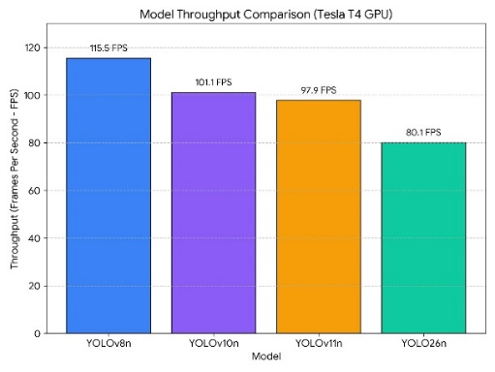
Fig 10. Model Throughput Comparison

Conclusion
This study introduced an adaptive traffic light system, which combines the YOLOv26 object detection model and fuzzy logic controller to enhance the management of traffic light signals. The best model for the detection performance was YOLOv26 with the precision of 0.9614, mAP@0.50:0.95 of 0.8113, which allowed for accurate real-time vehicle detection. The fuzzy logic controller was used to dynamically control the length of the green light, thereby minimizing the need for green light allocation and idle waiting time as compared to traditional fixed time traffic signal systems based on the traffic density detected. The results show the great effectiveness of the deep learning and fuzzy logic in implementation of intelligent traffic control. The proposed system was, however, only validated in a simulation environment with the use of a public vehicle dataset of Indonesia. The future work is suggested for real world deployment, synchronizing the intersection across the various intersections, adding more sensors like radar and thermal camera to the system and improving the fuzzy logic controller for the connected and autonomous vehicle world.
DATA AVAILABILITY
This study used a dataset that contained images of Indonesian vehicles from Roboflow. The link to access this dataset is available here https://universe.roboflow.com/arkhsat-project/indonesia-vehicle-ww6hv

REFRENCES
[1] M. Tubaishat, Y. Shang, and H. Shi, “Adaptive traffic light control with wireless sensor networks,” in 2007 4th Annual IEEE Consumer Communications and Networking Conference, CCNC 2007, 2007. doi: 10.1109/CCNC.2007.44.
[2] M. T. R. Kartono, N. K. Sari, and A. T. Suroso, “Smart Traffic Management System for Reducing Urban Congestion in Major Indonesian Cities Using IOT and AI Technologies,” Proceeding of the International Conferences on Engineering Sciences, vol. 2, no. 1, 2025.
[3] U. K. Lilhore et al., “Design and Implementation of an ML and IoT Based Adaptive Traffic-Management System for Smart Cities,” Sensors, vol. 22, no. 8, 2022, doi: 10.3390/s22082908.
[4] M. Ashkanani, A. AlAjmi, A. Alhayyan, Z. Esmael, M. AlBedaiwi, and M. Nadeem, “A Self-Adaptive Traffic Signal System Integrating Real-Time Vehicle Detection and License Plate Recognition for Enhanced Traffic Management,” Inventions, vol. 10, no. 1, 2025, doi: 10.3390/inventions10010014.
[5] S. M. Turjya, “A COMPREHENSIVE REVIEW OF YOLOV26 AND EXISTING YOLO VARIANTS: ARCHITECTURE, TRAINING PARADIGMS, AND APPLICATIONS IN MEDICAL AND GENERAL COMPUTER VISION,” 2026.
[6] A. Omari Alaoui, M. Oumoulylte, H. Oubalahcen, M. K. Boutahir, A. Hessane, and A. El Allaoui, “Real-time traffic signal adjustment using YOLOv8 for improved integration of emergency vehicles in smart traffic systems,” Signal Image Video Process., vol. 19, no. 7, 2025, doi: 10.1007/s11760-025-04210-8.
[7] M. A. Ottom and A. Al-Omari, “An Adaptive Traffic Lights System using Machine Learning,” International Arab Journal of Information Technology, vol. 20, no. 3, 2023, doi: 10.34028/iajit/20/3/13.
[8] H. D. Nguyen, H. D. Le, V. K. Nguyen, and H. M. Lam, “Development of the intelligent traffic light system based on image processing and fuzzy control techniques,” CTU Journal of Innovation and Sustainable Development, vol. 16, no. 3, 2024, doi: 10.22144/ctujoisd.2024.302.
[9] A. Abraham, D. Purwanto, and H. Kusuma, “Traffic Lights and Traffic Signs Detection System Using Modified You only Look Once,” in Proceedings - 2021 International Seminar on Intelligent Technology and Its Application: Intelligent Systems for the New Normal Era, ISITIA 2021, 2021. doi: 10.1109/ISITIA52817.2021.9502268.
[10] T. Mulya, V. Poekoel, J. Litouw, and R. Robot, “Perbandingan Kendali Proporsional dan Kendali Logika Fuzzy pada Lampu Lalu-lintas,” Jurnal Teknik Elektro dan Komputer, vol. 09, no. 1, 2020.
[11] J. Liu, “Enhancing Urban Traffic Management: A Comprehensive Study of Adaptive Control Traffic Light Systems,” Highlights in Science, Engineering and Technology, vol. 111, 2024, doi: 10.54097/m7eqkp82.
[12] K. Nautiyal, D. Gangodkar, and M. Diwakar, “Analysis on Advancements in Adaptive Traffic Lights System,” in Procedia Computer Science, 2025. doi: 10.1016/j.procs.2025.04.537.
[13] D. R. Aleko and S. Djahel, “An efficient adaptive traffic light control system for urban road traffic congestion reduction in smart cities,” Information (Switzerland), vol. 11, no. 2, 2020, doi: 10.3390/info11020119.
[14] I. Moumen, J. Abouchabaka, and N. Rafalia, “Adaptive traffic lights based on traffic flow prediction using machine learning models,” International Journal of Electrical and Computer Engineering, vol. 13, no. 5, 2023, doi: 10.11591/ijece.v13i5.pp5813-5823.
[15] G. I. Ortega, A. M. O. Ordas, J. F. Villaverde, R. A. Juanatas, and I. C. Juanatas, “Pedestrian-Based Adaptive Traffic Light Control Using YOLOv8,” in ICISS 2024 - Proceedings of the 7th International Conference on Information Science and Systems, 2025. doi: 10.1145/3700706.3700717.
[16] S. K. Abbas et al., “Vision based intelligent traffic light management system using Faster R-CNN,” CAAI Trans. Intell. Technol., vol. 9, no. 4, 2024, doi: 10.1049/cit2.12309.
[17] Z. Fahrunnisa, R. Rahmadwati, and R. A. Setyawan, “Adaptive Traffic Light Signal Control Using Fuzzy Logic Based on Real-Time Vehicle Detection from Video Surveillance,” Jurnal Ilmiah Teknik Elektro Komputer dan Informatika, vol. 10, no. 2, 2024, doi: 10.26555/jiteki.v10i2.28712.
[18] A. S. I. B. Arkanuddin, S. Sulistyo, and A. G. Persada, “Adaptive Traffic Light Control Based on Actual Condition Using Google Map API,” IJITEE (International Journal of Information Technology and Electrical Engineering), vol. 3, no. 2, 2019, doi: 10.22146/ijitee.49964.
[19] N. D. Aditya, R. Pratama, M. R. Piransyah, and N. Juita, “Revolutionizing Traffic Light Systems : AI Implementation For Efficiency And Safety,” Journal Of Social Science Research, vol. 5, 2025.
[20] R. F. D. Yudha, D. G. Astapati, F. K. Pamungkas, E. S. L. Toruan, and J. Prasetijo, “Impact of Intelligent Transportation Systems (ITS) on Traffic Improvement for Middle City Scale: A Systematic Literature Review (SLR),” RIGGS: Journal of Artificial Intelligence and Digital Business, vol. 4, no. 2, 2025, doi: 10.31004/riggs.v4i2.1465.
[21] S. Maadi, S. Stein, J. Hong, and R. Murray-Smith, “Real-Time Adaptive Traffic Signal Control in a Connected and Automated Vehicle Environment: Optimisation of Signal Planning with Reinforcement Learning under Vehicle Speed Guidance,” Sensors, vol. 22, no. 19, 2022, doi: 10.3390/s22197501.
[22] V. Tammisetti, G. Stettinger, M. P. Cuellar, and M. Molina-Solana, “Meta-YOLOv8: Meta-Learning-Enhanced YOLOv8 for Precise Traffic Light Color Detection in ADAS,” Electronics (Switzerland), vol. 14, no. 3, 2025, doi: 10.3390/electronics14030468.
[23] N. Tania and R. Rachmawati, “Area Traffic Control System (ATCS) for Supporting Urban Traffic Management in DKI Jakarta,” in 7th International Conference on Electric Vehicular Technology, ICEVT 2022 - Proceeding, 2022. doi: 10.1109/ICEVT55516.2022.9924924.
[24] F. Kurniawan, H. Agustian, D. Dermawan, R. Nurdin, N. Ahmadi, and O. Dinaryanto, “Hybrid Rule-Based and Reinforcement Learning for Urban Signal Control in Developing Cities: A Systematic Literature Review and Practice Recommendations for Indonesia,” Applied Sciences, vol. 15, no. 19, 2025.
[25] M. Almaliki, A. Bamaqa, M. Badawy, T. A. Farrag, H. M. Balaha, and M. A. Elhosseini, “Adaptive Traffic Light Management for Mobility and Accessibility in Smart Cities,” Sustainability (Switzerland), vol. 17, no. 14, 2025, doi: 10.3390/su17146462.
[26] M. Raza et al., “An Edge-Deployed Real-Time Adaptive Traffic Light Control System Using YOLO-Based Vehicle Detection and PCE-Aware Density Estimation,” IEEE Access, vol. 13, 2025, doi: 10.1109/ACCESS.2025.3602844.
[27] G. Wang, P. Jin, Z. Qi, and X. Li, “Traffic sign detection method based on improved YOLOv8,” Sci. Rep., vol. 15, no. 1, 2025, doi: 10.1038/s41598-025-03792-0.
[28] Krish Saurabh Mehta, Kush Nihar Raj, and Keyur Nayankumar Brahmbhatt, “Machine learning solutions for adaptive traffic signal control: A review of image-based approaches,” World Journal of Advanced Engineering Technology and Sciences, vol. 13, no. 1, 2024, doi: 10.30574/wjaets.2024.13.1.0437.
[29] A. Suhartono, “Lampu Lalulintas Adaptif untuk Simpangan Padat Menggunakan Simple Additive Weight,” Journal of Intelligent System and Computation, vol. 4, no. 1, 2022, doi: 10.52985/insyst.v4i1.222.
[30] V. B. Kamble, O. N. Mundhe, C. M. Walunjkar, and G. A. Kale, “AI-Driven Smart Traffic Management System: An Adaptive Approach Using YOLO and OpenCV,” International Journal of Multidisciplinary on Science and Management, vol. 2, no. 2, 2025.
[31] J. Kustija, “SCATS (Sydney Coordinated Adaptive Traffic System) As A Solution To Overcome Traffic Congestion in Big Cities,” International Journal of Research and Applied Technology, vol. 3, no. 1, 2023, doi: 10.34010/injuratech.v3i1.7875.

